Week 1 Weekend Assignment
"Network Detective Challenge"
Due: End of Week 1 (before Day 5 test) | Time estimate: 3-4 hours across Saturday + Sunday What you need: Your own laptop/PC, Wireshark (free), internet connection, this document

NAME: TRISHNA G

The Big Picture
Over the past 4 days you learned:
- Day 1: What cybersecurity is — CIA Triad, AAA, threats vs vulnerabilities vs risks
- Day 2: Networking basics — OSI model, TCP/IP, IP addressing, ports, protocols
- Day 3: Common protocols — HTTP/HTTPS, FTP/SFTP, SSH, SMTP, DNS, ICMP + subnetting
- Day 4: Linux & Windows security — permissions, users, hardening, event logs
Now it is time to combine all of that into one real-world mini-project. This assignment has 3 parts. Do all 3. They build on each other.

Part 1 — Capture & Analyze HTTP Traffic (Day 2 + Day 3 skills)
What to do:
- Install Wireshark (if not already): https://www.wireshark.org/download.html
- Open Wireshark and start capturing on your active network interface (Wi-Fi or Ethernet).
- While capturing, open a browser and visit 3 different websites:
  - One that uses HTTP (try http://neverssl.com — it deliberately uses HTTP)
  - One that uses HTTPS (try https://www.google.com)
  - One of your choice (any site you normally use)
- Stop the capture after about 60 seconds of browsing.
- Apply the display filter http in Wireshark — this shows only HTTP traffic.
- Also try the filter dns to see DNS queries.
- Also try the filter tcp.port == 443 to see HTTPS traffic.
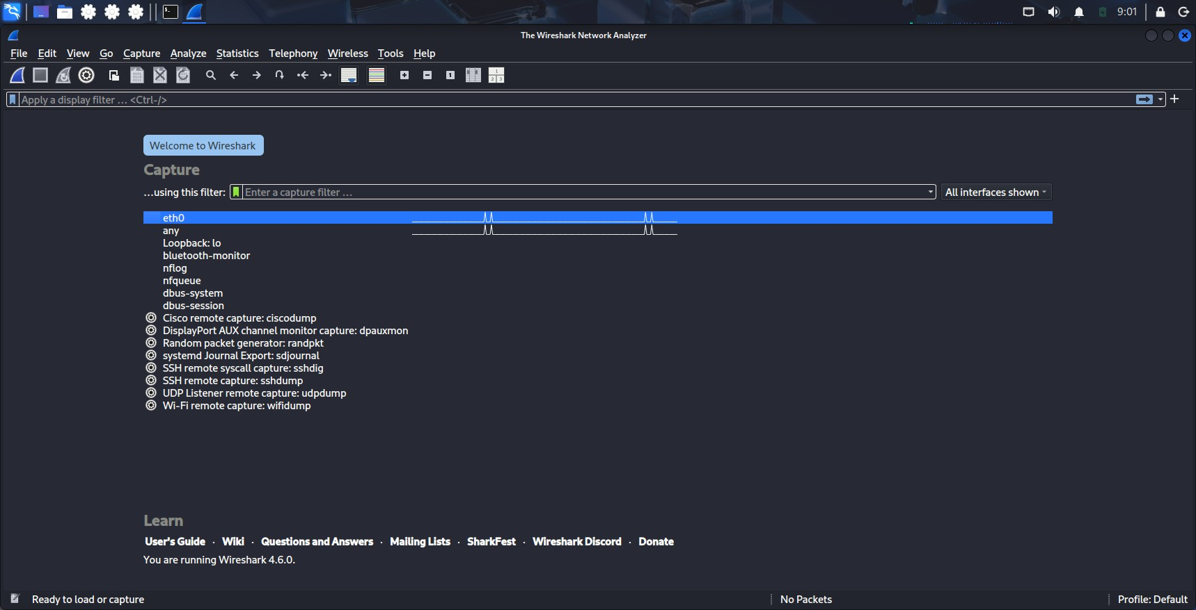

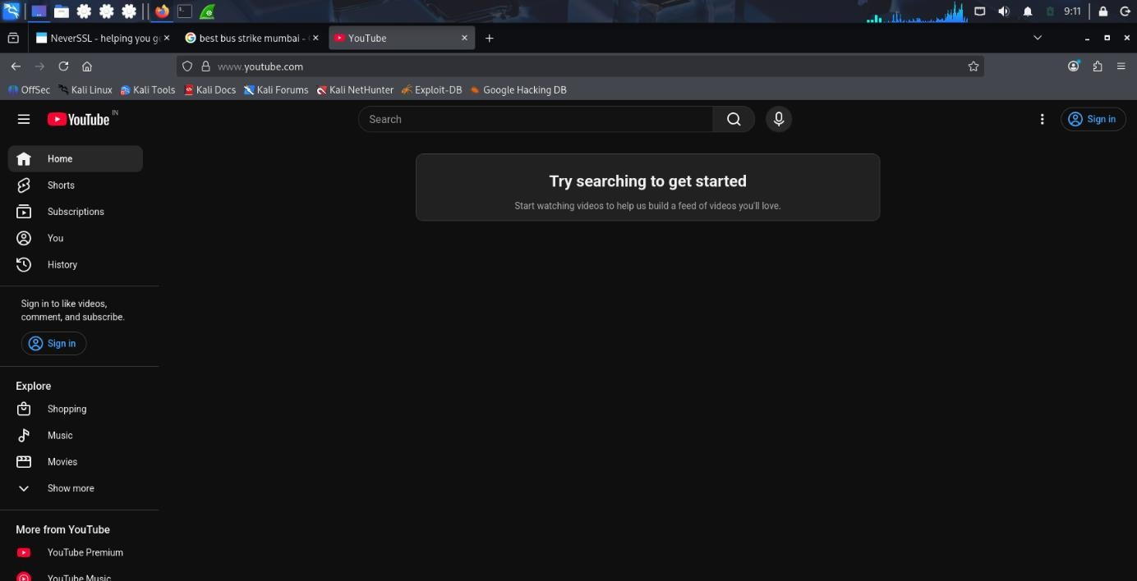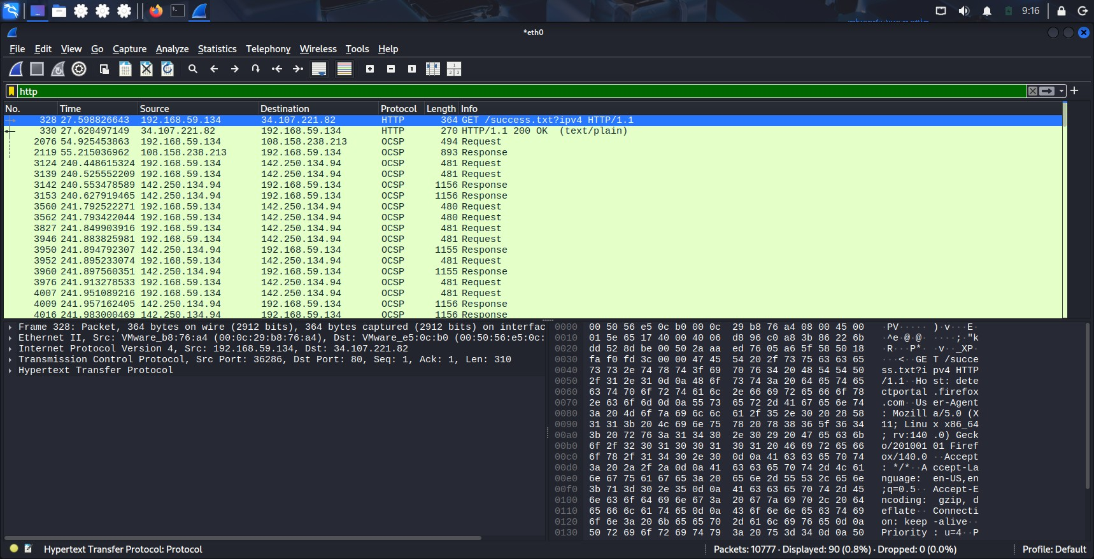

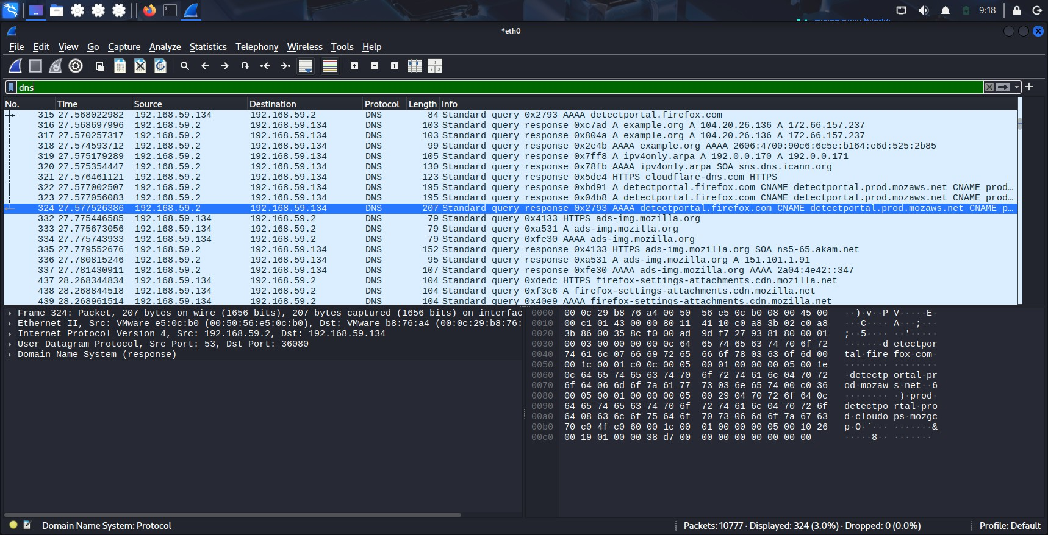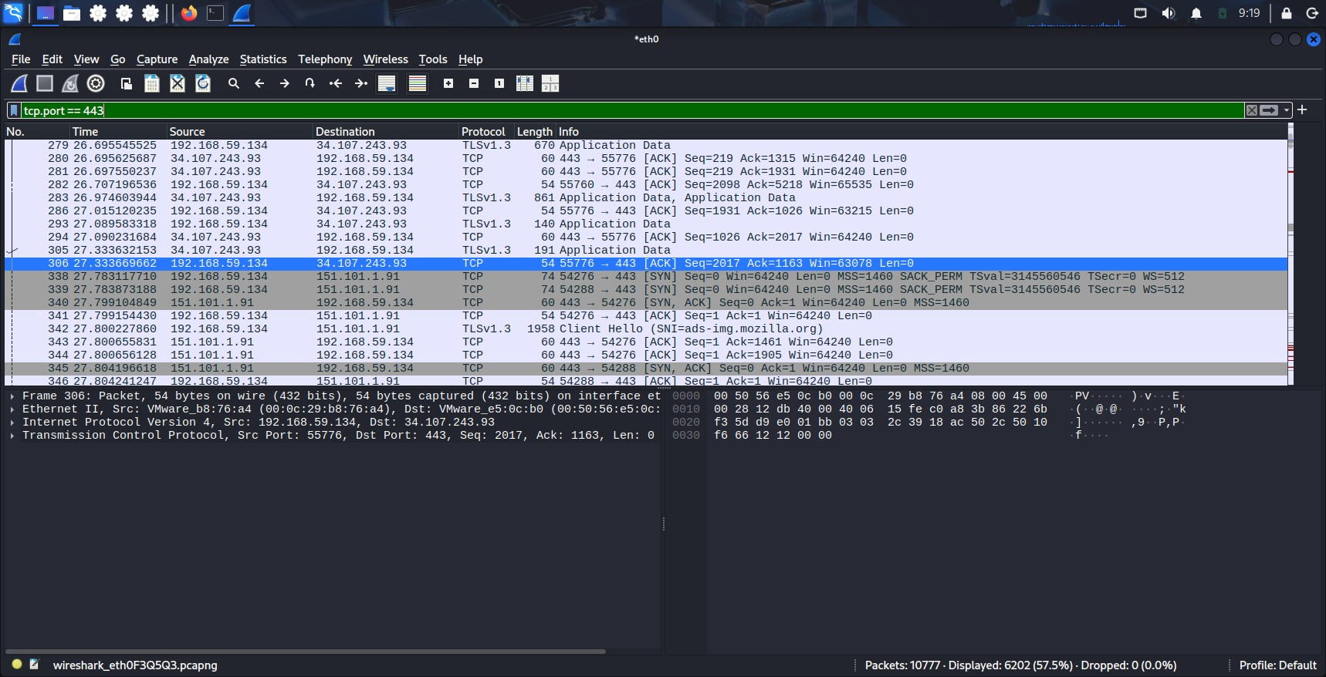
What to write about (answer in your own words):
For each of the 3 websites, answer:
Question | Your answer
What website did you visit? | Neverssl, Google and Youtube
HTTP or HTTPS? How can you tell from the capture? | Neverssl – HTTP, google and youtube - HTTPS
What IP address did your computer connect to? | 192.168.59.134
What was the destination port? (80 or 443?) | For neverssl it’s 80 and for google and youtube it’s 443
For HTTP sites: what information is visible in the packet? | HTTP packets are visible in Wireshark because they are not encrypted. Information like the website address, request details, headers, and webpage data can be seen directly in the packet.
For HTTPS sites: what information is visible vs hidden? | HTTPS packets show connection details like IP addresses, port 443, and TLS information, but the actual data being transferred is hidden because it is encrypted.
What DNS queries did you see before the connection? | 72 Standard query 0x405c A neverssl.com  70 Standard query 0xf56b A google.com  75 Standard query 0x7089 A www.youtube.com
Key concepts to connect:
- CIA Triad: When you visited the HTTP site, which part of CIA was violated? (Hint: no encryption = no Confidentiality) ---- When accessing an HTTP website, the main security principle affected is Confidentiality.
HTTP does not encrypt the communication between the user and the server. During packet capture in
Wireshark, the transmitted information such as website requests, headers, and other data can be viewed in plain text. This means an attacker monitoring the network can read the exchanged information.

- AAA: If the HTTP site had a login page, which AAA function would be exposed? (Hint: Authentication credentials in clear text) ---- When accessing an HTTP website, the main security principle affected is Confidentiality. HTTP does not encrypt the communication between the user and the server. During packet capture in Wireshark, the transmitted information such as website requests, headers, and other data can be viewed in plain text. This means an attacker monitoring the network can read the exchanged information.

- Subnetting: What is the IP range of your home network? (Check with ipconfig or ifconfig) What subnet mask is you using? ---- IP Address: 192.168.59.134
Subnet Mask: 255.255.255.0
CIDR Notation: /24
Network Address: 192.168.59.0
Network Range: 192.168.59.0 – 192.168.59.255
Usable Host Range: 192.168.59.1 – 192.168.59.254
Broadcast Address: 192.168.59.255
Where to get help / sources:
- Wireshark official docs: https://www.wireshark.org/docs/
- Wireshark 101 tutorial: https://www.youtube.com/watch?v=TkCSr30UojM
- How to filter HTTP traffic: In Wireshark, type http in the display filter bar

Part 2 — Subnetting Practice (Day 3 skills)
Using what you learned about subnetting in Day 3, solve these problems. Show your working.

Problem 1
Your home router gives you the network 192.168.1.0/24.
- How many total host addresses are available in this network?
Ans. 254 usable host addresses

- If you split it into 4 equal subnets, what is the new subnet mask in CIDR notation?
Ans. /26 (255.255.255.192)

- What are the network addresses of all 4 subnets?
Ans. 192.168.1.0
192.168.1.64
192.168.1.128
192.168.1.192

- What is the broadcast address of the third subnet?
Ans. 192.168.1.191

- How many usable hosts per subnet after splitting?
Ans. 62 usable hosts per subnet.

Problem 2
You are a network admin for a small office. You have these departments:
- Sales: needs 30 hosts
- Engineering: needs 50 hosts
- HR: needs 10 hosts
- Servers: needs 10 hosts
You are given the network 10.0.0.0/24.
- Design a subnetting scheme that gives each department enough addresses.
- For each department, write: network address, subnet mask (CIDR), usable host range, broadcast address. Ans. Engineering (Needs 50 hosts) Needs the largest subnet. For 50 hosts:
  - Required addresses = 64
  - Subnet = /26
  - Usable hosts = 62
Network Address: 10.0.0.0/26 Subnet Mask: 255.255.255.192 Usable Host Range:
10.0.0.1 – 10.0.0.62 Broadcast Address:
10.0.0.63

Sales (Needs 30 hosts) For 30 hosts:
  - Required addresses = 32
  - Subnet = /27
  - Usable hosts = 30
Network Address: 10.0.0.64/27 Subnet Mask: 255.255.255.224 Usable Host Range: 10.0.0.65 – 10.0.0.94 Broadcast Address:
10.0.0.95

HR (Needs 10 hosts) For 10 hosts:
  - Required addresses = 16
  - Subnet = /28
  - Usable hosts = 14
Network Address: 10.0.0.96/28 Subnet Mask: 255.255.255.240 Usable Host Range: 10.0.0.97 – 10.0.0.110 Broadcast Address:
10.0.0.111

Servers (Needs 10 hosts) For 10 hosts:
  - Required addresses = 16
  - Subnet = /28
  - Usable hosts = 14
Network Address: 10.0.0.112/28 Subnet Mask: 255.255.255.240 Usable Host Range: 10.0.0.113 – 10.0.0.126 Broadcast Address:
10.0.0.127

- Which department gets the largest subnet? Why?
Ans. Engineering requires 50 hosts, which is the highest requirement among all departments. A /26 subnet provides 62 usable host addresses, which is enough for all Engineering devices while avoiding unnecessary IP address wastage.

Problem 3 — Connect to Security
- Why would a security team want to put the Servers department on a different subnet from Sales? (Answer using
CIA + AAA concepts)
Ans. A security team would separate the Servers department from Sales by placing them on different subnets to improve network security. This helps protect important server data and systems from unauthorized access.
From the CIA Triad perspective, subnet separation improves Confidentiality because Sales users should not have direct access to sensitive server information. It also improves Integrity by reducing the chance that a compromised Sales computer can modify or damage server data. Availability is improved because security issues in the Sales network are less likely to affect critical servers.
From the AAA framework, separating subnets helps with Authorization because users in Sales can be given only the access they actually need. Being connected to the company network does not mean every user should be allowed to access servers.

- If an attacker compromises a Sales PC, can they directly access a Server on a different subnet? Explain why or why not.
Ans. No, the attacker cannot directly access the Server subnet in most secure networks. When networks are divided into different subnets, communication between them must pass through a router or firewall.
The router/firewall checks the traffic and applies security rules. If the company has proper firewall rules, it can block Sales devices from accessing sensitive Server systems. This prevents attackers from easily moving from one part of the network to another after compromising a device.

- What device controls traffic between subnets? (Hint: think about Day 2 — routers/firewalls)
Ans. A router allows communication between different networks, while a firewall adds security by inspecting traffic and deciding what connections are allowed or blocked. In an organization, these devices help control access between departments and protect important systems like servers.

Part 3 — Connect Everything: CIA + AAA Across All 4 Days
This is the thinking part. Write short paragraphs (3-5 sentences each). No copy-paste — use your own words.

Question 1 — CIA Triad in Action
Pick one of the protocols you studied (HTTP, FTP, SMTP, DNS, SSH, or ICMP). For that protocol:
- How does it support one part of the CIA Triad?
Ans. HTTP supports Availability because it helps users access websites and communicate with web servers easily. It allows information and web pages to be delivered whenever users request them, making online services available.

- How does it fail to protect one part of the CIA Triad?
Ans. HTTP fails to protect Confidentiality because the data sent between the user and the website is not encrypted. This means an attacker who captures the traffic may be able to see the information being transferred.

- What would a security professional do to fix that weakness?
Ans. A security professional would replace HTTP with HTTPS, which uses encryption to secure the communication. They would also make sure websites use valid security certificates and follow secure communication practices.

Question 2 — AAA Framework in Action
Think about logging into a website (like Gmail or any site you use).
- Authentication: How does the site verify you are who you say you are?
Ans. Authentication.

- Authorization: After you log in, what are you allowed to do? What are you NOT allowed to do?
Ans. After logging in, authorization decides what actions you are allowed to perform. For example, you can read your own emails and send messages, but you cannot access another person's emails or change settings you do not have permission to modify.

- Accounting: What records might the site keep about your login? Why?
Ans. It may store information like login time, device details, IP address, and failed login attempts. These records help detect suspicious activity and improve security.
Now answer: What happens if an attacker captures your HTTP traffic from Part 1? Which part of AAA breaks first? Why?
Ans. If an attacker captures HTTP traffic, Authentication breaks first because HTTP does not encrypt data. The attacker may be able to see usernames, passwords, or login information sent between the user and the website. If they get these details, they can pretend to be the real user and access the account, which can later affect authorization and accounting as well.

Question 3 — The Full Attack Story
Imagine this scenario:
An employee at a company uses an unencrypted HTTP connection to log into the internal HR portal from a coffee shop. The company's network is poorly segmented — all departments are on the same subnet 192.168.1.0/24.
Using everything you learned this week, write a short attack story:
- What can the attacker on the coffee shop Wi-Fi see? (Day 3 — HTTP, packet capture)
Ans. The attacker on the coffee shop Wi-Fi can capture the employee's network traffic using packet capture tools like Wireshark. Because the connection uses HTTP, the data is not encrypted, so the attacker may be able to see sensitive information such as the username, password, and details being sent between the employee and the HR portal.

- What can the attacker do with those credentials? (Day 1 — Authentication broken, CIA violated)
Ans. Once the attacker gets the employee's login credentials, they can use them to log into the HR portal as that employee. This breaks Authentication because the system cannot tell the difference between the real user and the attacker. It also affects the Confidentiality of the CIA Triad because private employee information can be accessed.

- Once inside the company network, what can the attacker reach? (Day 3 — subnetting, no segmentation)
Ans. Because the company uses one large subnet (192.168.1.0/24) for all departments, the attacker may be able to reach systems across the entire network. Without proper segmentation, a compromised employee device could allow the attacker to scan and access other departments like HR, Sales, Engineering, or servers more easily.

- How could the company have prevented this? (Day 4 — hardening, Day 3 — segmentation, Day 1 — controls)
Ans. The company could prevent this by using HTTPS instead of HTTP so login details are encrypted. They should also separate departments into different subnets using network segmentation and apply firewall rules to control access. Additional security measures like multi-factor authentication, strong passwords, regular updates, and monitoring login activity would make it harder for attackers to gain access.

Question 4 — Linux/Windows Connection
- On Day 4 you learned about file permissions (Linux) and Event Viewer (Windows).

- How does the principle of least privilege (Day 4) connect to the AAA Authorization function (Day 1)?
Ans. The principle of least privilege means giving users only the permissions they actually need to do their work. This is connected to AAA Authorization because authorization decides what actions a user is allowed to perform after they log in. For example, a normal employee should not have administrator access because they do not need permission to change important system settings.

- If an attacker gets a shell on a Linux machine, what permission-related files would they look for?
Ans. If an attacker gets access to a Linux system, they may look at files like /etc/passwd and /etc/shadow to understand user accounts and password information. They may also check permission settings, ownership of files, and sudo configuration to find ways to gain higher privileges.

- On Windows, where would you look in Event Viewer to spot a brute-force login attempt?
Ans. On Windows, a security professional would check Event Viewer → Windows Logs → Security. They would look for repeated failed login events, especially Event ID 4625 (Failed login attempt), which can indicate a possible brute-force attack. Monitoring these logs helps identify suspicious login activity.

How to Submit
Create a single document (text file, markdown, or PDF) with:
- Part 1: Your traffic analysis table + answers + at least 2 screenshots from Wireshark
- Part 2: All subnetting answers with working shown
- Part 3: All 4 written answers in your own words
Name it: Week1_Weekend_Assignment_YourName.md (or .txt or .pdf)

Grading Rubric (self
-
grade before submitting)

Criteria

Points

Your score

Part 1: Traffic captured and analyzed correctly

/25

Part 1: CIA + AAA
connections made

/10

Part 2: Subnetting calculations correct

/25

Part 2: Security reasoning about subnets

/10

Part 3: Own words, no copy
-
paste

/15

Part 3: Connections across all 4 days are accurate

/15

Total

/100

Tips for Doing This

Well

- Do Part 1 first. It is the most hands-on and will make the theory in Parts 2 and 3 feel real.
- Use your notes from all 4 days. This assignment is designed to make you go back and review everything.
- If you get stuck on subnetting, re-read the Day 3 notes. The 192.168.1.0/24 example is your starting point.
- Screenshots matter. In cybersecurity, evidence matters. Show what you captured.
- Write like you are explaining to a friend. If you cannot explain it simply, you do not understand it yet.

